13点40分 2021年11月20日星期六

<https://hackernoon.com/14-patterns-to-ace-any-coding-interview-question-c5bb3357f6ed>

<https://leetcode.com/problems/reverse-bits/discuss/54838/interesting-c-code-and-i-find-this-in-the-computer-graphics-course-time-is-3ms>

14点33分 2021年11月20日星期六

计算机图形学的Leetcode

<https://towardsdatascience.com/enhance-your-python-project-code-with-classes-5a19d0e9f841>

对开头的class solution()疑惑。现在查上面的参考。

14点48分 日期

解决罗马数字问题。

Questions to be asked:

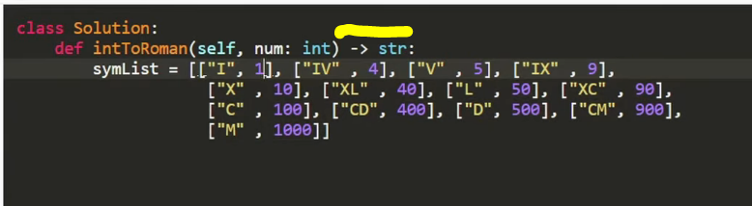

What the pointer means.

'''

Roman numerals are represented by seven different symbols: I, V, X, L, C, D and M.

Symbol Value

I 1

V 5

X 10

L 50

C 100

D 500

M 1000

For example, two is written as II in Roman numeral, just two one's added together. Twelve is written as, XII, which is simply X + II. The number twenty seven is written as XXVII, which is XX + V + II.

Roman numerals are usually written largest to smallest from left to right. However, the numeral for four is not IIII. Instead, the number four is written as IV. Because the one is before the five we subtract it making four. The same principle applies to the number nine, which is written as IX. There are six instances where subtraction is used:

I can be placed before V (5) and X (10) to make 4 and 9.

X can be placed before L (50) and C (100) to make 40 and 90.

C can be placed before D (500) and M (1000) to make 400 and 900.

Given a roman numeral, convert it to an integer. Input is guaranteed to be within the range from 1 to 3999.

'''

class Solution:

def romanToInt(self, s: 'str') -> 'int':

value_roman = {"M":1000, "CM":900, "D":500, "CD": 400,

"C":100,"XC":90, "L":50, "XL":40,

"X":10, "IX":9, "V":5, "IV":4, "I":1}

num = 0

specials_list = ["CM","CD","XC","XL","IX","IV"]

for i in specials_list:

if i in s:

num = num + value_roman[i]

s=s.replace(i,"")

for i in s:

num = num + value_roman[i]

return(num)

运行成功

Longest Common Prefix

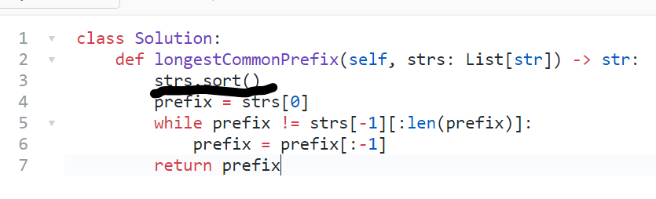

Strs.sort()看不懂，答案如下

<https://realpython.com/python-sort/>

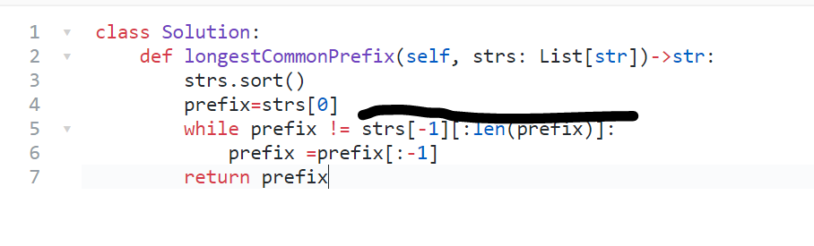这个双[ ] [ ]是什么东西。

18点53分 2021年11月26日星期五

**表示^ 即乘方

<https://www.freecodecamp.org/news/python-for-loop-for-i-in-range-example/>

看这里讲解for loop

<https://careerkarma.com/blog/python-len/>

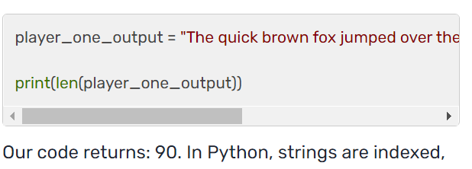

没有中括号，返回字母，有中括号，返回单词

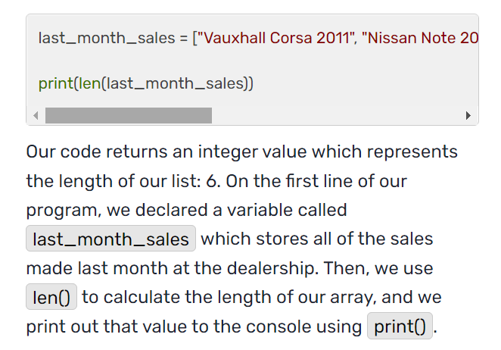

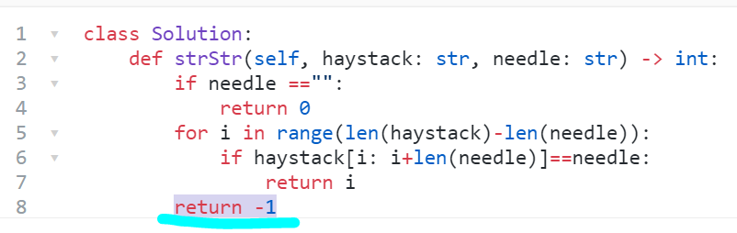

Why return -1 comes outside of the function?

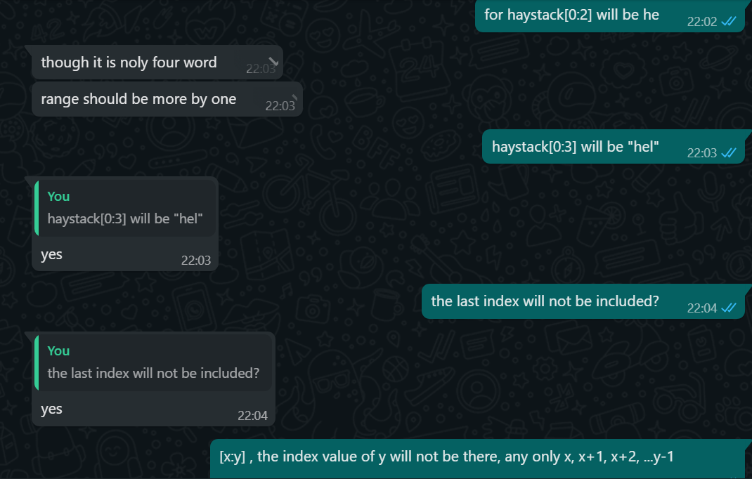

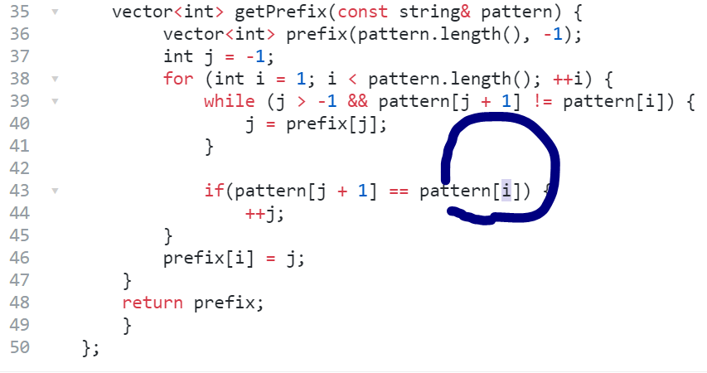

问题就算 这个字母抄错了。i 对 j 不对